

Year 6   
Term 2.1   
Geography

Knowledge Organiser – Mountains

What a mountain is

A **mountain** is a **landmass** that has a naturally occurring **elevation**. **Mountains** are usually taller and **steeper** than **hills**. A **hill** is usually anything under 300m high and a **mountain** anything over 300m. **Mountains** normally reach to a pointed **peak** or a **summit** whereas **hills** generally have more rounded **peaks**.

Important Topic Vocabulary

**base** The bottom of the mountain were it meets the flat ground.

**face** The vertical surface or side of a mountain.

**glacier** A mountain glacier is formed by compacted snow into ice.

**plateau** A flat part of land high up on the mountain.

**range** A range of mountains or hills is a line of them.

**ridge**  A long narrow top connecting mountains.

**tree line**  After this point, trees cannot grow.

**slope**  An incline or decline on the side of a mountain.

**snow line** Above this line snow covers the mountain all year. round.

**summit** The summit of a mountain is the top of it.

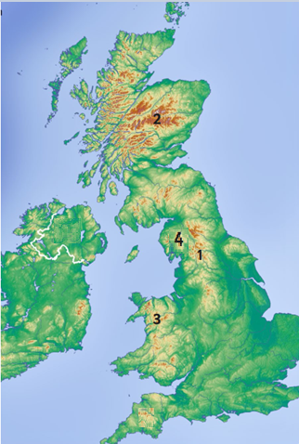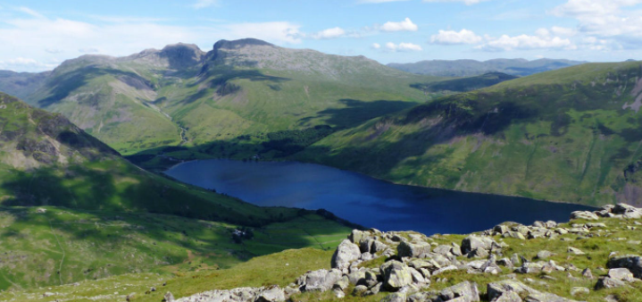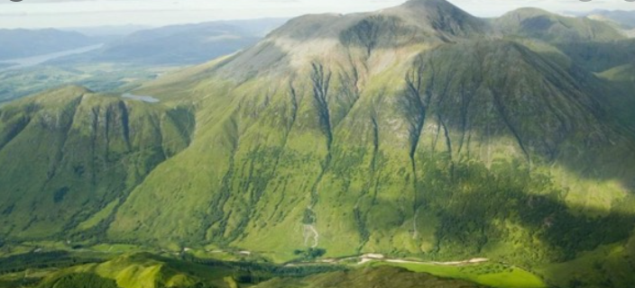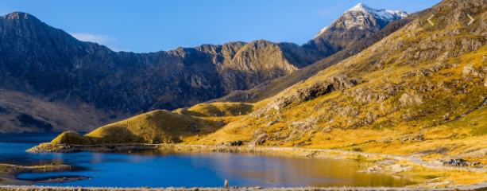

**What you should already know…**

Know a volcano is a conical shaped hill or mountain within the Earth’s surface that contains a crater/vent through which lava, rocks and gas erupt. Know that there are three types of volcano. These are extinct, active and dormant. Know the Earth’s tectonic plates are constantly moving. Contour lines are lines on a map joining points of equal height above or below sea level.

The continents of the world are: Europe, Asia, North America, South America, Africa, Australasia and Antarctica.

**1   
Pennines in North West England.**

**2   
Grampian Mountains, in Scotland.**

**3 Snowdonia in North West Wales.**

**4   
Southern Fells in Cumbria, North West, England.**

**Map of the UK.**

**valley** The area of low land between mountains.

4

1

3

2

This is Scafell Pike (978m). It is the highest mountain in England and is in the Lake District National Park. It is part of the Southern Fells Mountain range in Cumbria.

This is Ben Nevis (1345m). It is the highest mountain in the UK. It is part of the Grampian Mountains in Scotland.

This is Snowdon (1085m). It is the highest mountain in Wales and is found in Snowdonia National Park.

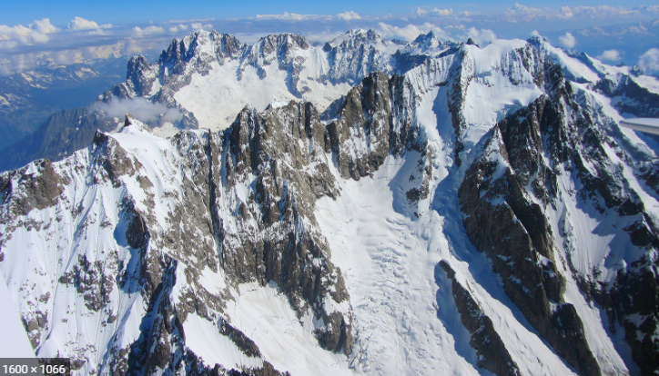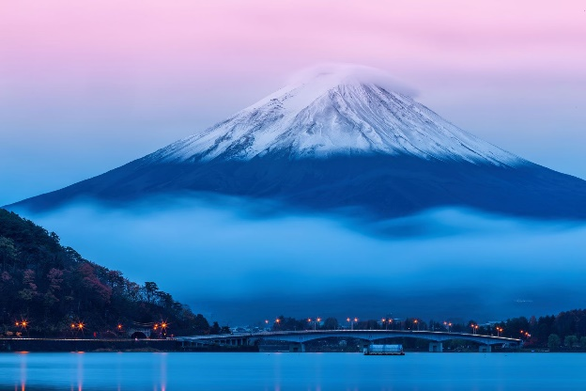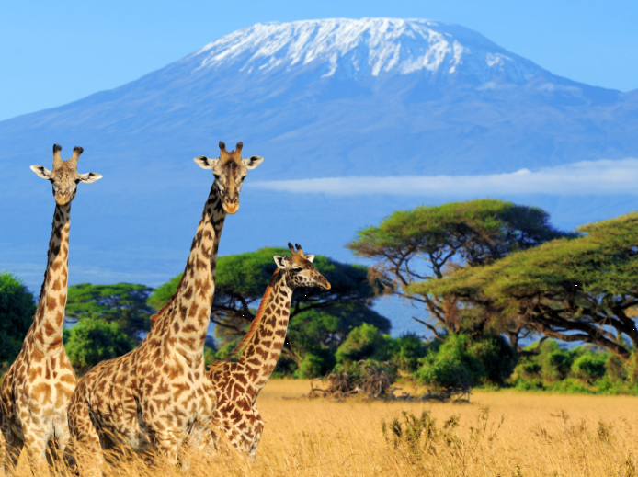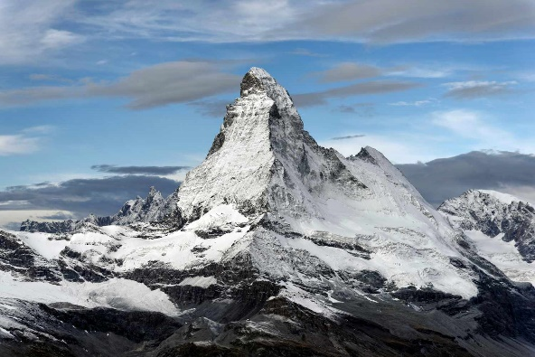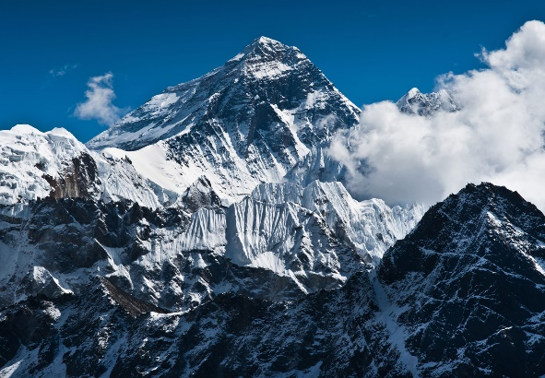

Mount Kilimanjaro is 5, 895m in Tanzania. It is the highest mountain in Africa.

Mount Everest is in the Himalayas and it is   
8, 848m. It is the highest mountain in the world. Most of the highest mountains in the world are part of the Himalayas.

Mount Fuji is an active volcano in, Japan. It is the country’s highest peak at 3, 776m.

The Matterhorn is a mountain in the Alps on the border between Switzerland and Italy. It is 4, 478m high.

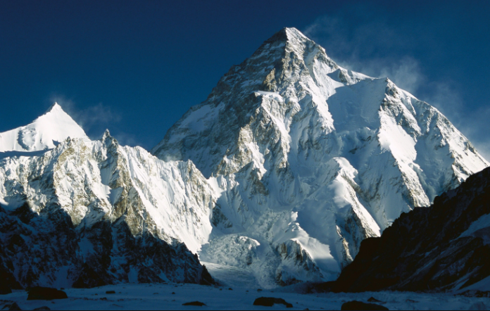

Mont Blanc is in the Alps in France. It is 4, 810m. It means ‘white mountain’ in French and is the highest mountain in the Alps.

K2 is in Baltoro Karakoram in Pakistan. It is 8,611m. It is the second highest mountain in the world.

**Mountain climates**

Mountains have their own climates because of their high altitude. This means that even mountains in warm countries by the Equator can have snow on their peaks all year round because the higher up the mountain you go the colder the climate becomes.

The climate on Mount Everest is extreme. The average temperature at the summit is -37oC but temperatures can reach around -60oC. From June to September Mount Everest experiences the Indian monsoon season when winds and rain blow in from the Indian Ocean.

**How are mountains used by humans?**

Mountains are used for different reasons by lots of different groups of people. Water companies, for example, take advantage of the fresh water springs on mountains and create reservoirs to provide towns and cities with water. People who live on the mountains use them to rear animals who graze on the mountain grass.

Mountains are also used as tourist destinations by millions of holiday-makers every year. Tourists visit mountains to explore the scenery, and to go for walks and hikes. They may take part in winter sports such as skiing or snow-boarding, or summer activities like paragliding or abseiling. Some tourists visit mountains to climb the peak as a personal challenge.